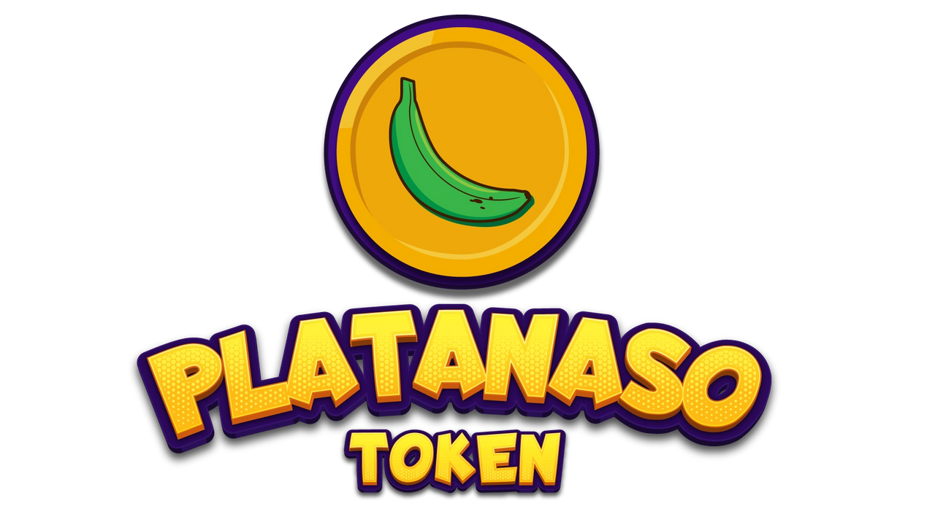

Disclaimers

Licenses and approvals are not assured in all jurisdictions Platanaso (“Platanaso.com”) intends to operate in full compliance with applicable laws and regulations and use its best endeavors to obtain the necessary licenses and approvals. Regulatory support and permissions are likely to be required in several relevant jurisdictions in which appropriate activities may take place. This means that the development and roll-out of all the initiatives described in this whitepaper are not guaranteed. It is not possible to ensure, and no, a person makes any representations, warranties, or assurances that any such licenses or approvals will be obtained within a particular timeframe or at all. As such, the initiatives described in this whitepaper may not be available in certain jurisdictions or at all. This could require restructuring of these initiatives and their unavailability in all or certain respects. In addition, the development of any initiatives is intended to be implemented in stages. During certain stages of development, the project may rely on relationships with certain licensed third-party entities. If these entities are no longer appropriately licensed in the relevant jurisdiction, this will impact the ability of platanaso.com to rely on the services of that party.

No advice This whitepaper does not constitute any investment advice, financial advice, trading advice, or recommendation by platanaso, its affiliates, or its respective officers, directors, managers, employees, agents, advisors or consultants on the merits of purchasing PLNT, nor should it be relied on upon in connection with any other contract or purchasing decision. Not a sale of a security

This whitepaper does not constitute a prospectus or financial service offering.

Document. It is not an offer to sell or solicitation to buy security, investment products, regulated products, or financial instruments in any jurisdiction. PLNT tokens are not being structured or sold as securities on Platanaso.com. Owners of PLNT tokens are not entitled to any rights in Platanaso. com or any of its affiliates, including any equity, shares, units, royalties too capital, profit, returns, or income in Platanaso.com or any other company or intellectual property associated with Platanaso.com

Platanaso (PLNT) is a community-driven token that rewards holders while at the same time providing much-needed donations to Tropical communities for humanitarian causes. Every week, a donation will be made based on the project’s market cap.

Platanaso (PLNT) is a donation-based and community-driven token created on the Binance Smart Chain (BSC)

Blockchain to donate towards humanitarian efforts in the Tropical community. We aim to contribute as much as 300 BNB (an increase from the earlier 100 BNB target) towards this effort.

Developers of this project saw an opportunity to disrupt a polluted token ecosystem filled with scam tokens and rug pulls (removing liquidity, thus allowing no buy/sell transaction to happen). Pumps and dumps are the names of the game in this field. There are no actual donation tokens for a highly sentimental and pressing cause, such as the Tropical communities in the ecosystem.

At the same time, we realize that the power of blockchain allows for anyone to participate in a permissionless, trustless, and thoroughly transparent environment. No intermediary is needed to Participate in any projects. It’s the Web 3.0

revolution, and it’s here. Thus, upon seeing these obvious gaps, Platanaso was born.

• Community Donation-based token

• Every transaction will attract a 16% fee

7 % will go to existing holders as rewards

4% will go towards a locked liquidity pool

5% will go towards a Marketing/Donation Wallet

• Liquidity is locked and after will be a lock 1 year (unable to rug pull)

• Donation to be made upon achieving a market capitalization

milestone

All PLNT holders will also get an opportunity to get in on early NFT airdrops